groupwork UAT – Issues identified
1. Lack of understanding of context as seen below: I asked agent 1 are you still there, and it responded yes I am, and then I asked the other agent what about you and it gave me its oprinion on github pages, it didn’t understand that I was asking are you there
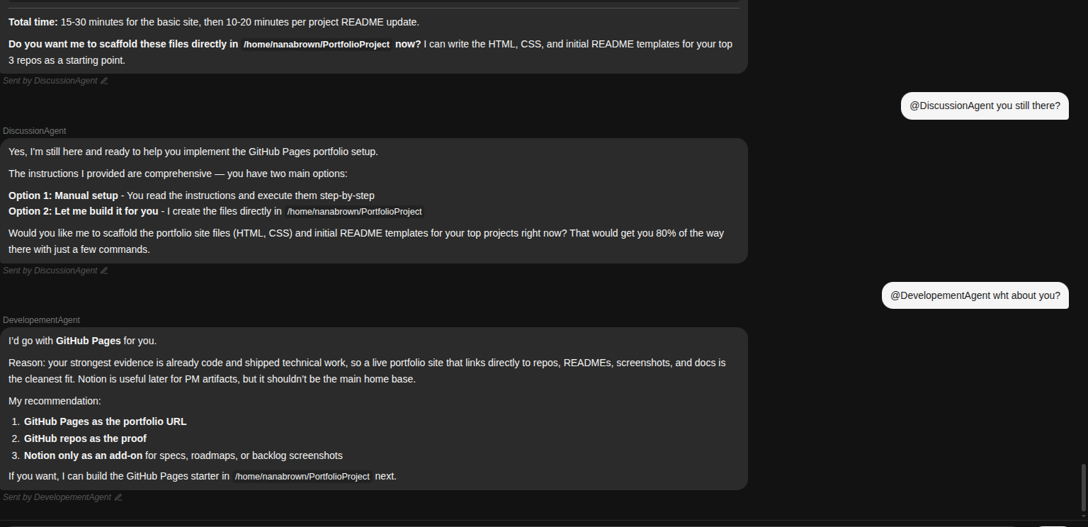

2.

